1. Emergency room data. (ER)

Event.drugindication == ER.Episode Disease

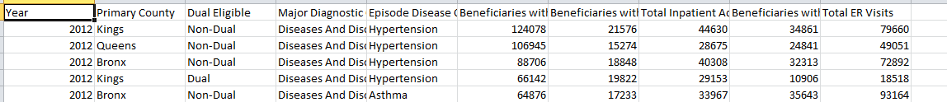

Result Table

|  |  |
| --- | --- |
| Year | Total ER Visits |
|  |  |
|  |  |

*Data available only for the state of New York for 2012.

Data Download from

<http://www.healthdata.gov/dataset/medicaid-chronic-conditions-inpatient-admissions-and-emergency-room-visits-county-beginnin-0>

1. **Discharge Data**

Event.drugindication == DischargeData. APR DRG Description

See attached file.

Result Table

|  |  |
| --- | --- |
| Date MM/YYYY | No. of Patient discharges. (Count of the rows.) |
|  |  |
|  |  |

*Data available only for the state of New York for 2009 to 2013.

Download Data from

2013

<http://www.healthdata.gov/dataset/resource/c77ebf0e-4189-4bd8-b887-be269520ebf9>

2012

<http://www.healthdata.gov/dataset/hospital-inpatient-discharges-sparcs-de-identified-2012/resource/e22c5e7a-a8a2-4f71-884e>

2011

<http://www.healthdata.gov/dataset/hospital-inpatient-discharges-sparcs-de-identified-downloadable-file-2011/resource/e83d7f46>

2010

<http://www.healthdata.gov/dataset/hospital-inpatient-discharges-sparcs-de-identified-2011/resource/248dbcd4-037d-42f8-a5cf>

2009

<http://www.healthdata.gov/dataset/hospital-inpatient-discharges-sparcs-de-identified-downloadable-file-2009/resource/8fc44f31>